Spanish Summer Work:
Complete preparation work and send to Miss Mallo for feedback.
Study for Controlled Assessments which will be taking on the dates assigned (PLEASE SEE BELOW) .
If the student feel they are prepared to succeed, they could take them before the set deadline notifying Miss Mallo first.
If the controlled assessment is Speaking revision should be practiced aloud as well as written to improve fluency and pronunciation. (www.fromtexttospeech.com
Revision should be…
- Proactive: Look, cover, test & check.
- Regular and repetitive (short periods of time with little breaks in between).
- Planned but also improvised (be always ready to do a little of revision in journeys, waiting moments…)
Students will also have to study Vocabulary from The GCSE Vocabulary Booklet or/and Memrise.
MEMRISE will allow students, parents and Miss Mallo to manage TIME and track PROGRESS.
IMPORTANT DATES (EACH task is 15 % of GCSE Spanish)
- TASK: Topic Environment Wed 14th September
- TASK: Topic School Writing Wed 28th September
- TASK: Topic Health Speaking Wed 12th October
- TASK: Topic Holidays Speaking Wed 2nd November

GCSE AQA Spanish Course (General Information)
UNIT 1
Listening = 20% of final marks (GCSE exam to be sat in June 2017) in either Higher or Foundation Tier on the 4 topics & 9 subtopics listed below.

UNIT 2
Reading = 20% of final marks (GCSE exam to be sat in June 2017) in either Higher or Foundation Tier on the 4 topics & 9 subtopics listed below.

UNIT 3
Speaking= 30% of final marks
Students take part in two speaking tasks.
Students get recorded taking part in a conversation with teacher.
TASK 1 Topic Holidays (15 %) Wed 2nd November
TASK 2 Topic Health (15%) Wed 12th October

UNIT4
Writing = 30% of final marks
Students complete essays during class time in exam conditions.
TASK 1 Topic School (15 %) Wed 28th September
TASK 2 Topic Environment (15%) Wed 14th September

If students are planning to be absent on these dates they should take it just before the date set (Please notify Miss Mallo before)
If students are unexpectedly absent on the date set, students will be expected to take their assessment the first Spanish lesson back. (Please notify Miss Mallo first day back to school at the beginning of the day)
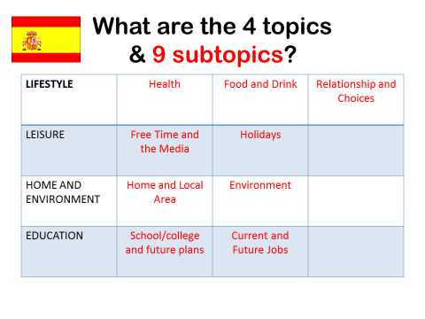

Resources ONLINE
All resources are available at www.missmallo.weebly.com
Other websites to revise from
www.memrise.com
www.kerboodle.com
www.quizlet.com
http://revisionworld.com/gcse-revision/spanish
http://www.languagesresources.co.uk/links.html
Remember to listen to Spanish music & songs, podcasts… you can also watch Spanish television, documentaries or films. Practice your Spanish everywhere, on your holidays, teach your younger brother or sister.
COMMUNICATION with Miss Mallo (for both parents & students).

Please feel free to use my email to ask any questions or clarification.
Please write student´s name in the subject of the email.
s.mallo@lifesciencesutc.co.uk

