GCSE Psychology
Exam board: AQA
Unit 1 year 10 (5 topics) and unit 2 year 11 (5 topics)
Unit 1: Making sense of other people | Exam Paper out of 80 marks
Topic 1: Memory | 15/80 marks
Topic 2: Non-verbal communication | 15/80 marks
Topic 3: Personality | 15/80 marks
Topic 4: Prejudice, stereotyping and discrimination | 15/80 marks
Topic 5: Research Methods | 20/80 marks
Unit 2: Understanding other people
Topic 6: Learning | 15/80 marks
Topic 7: Social Influence | 15/80 marks
Topic 8: Sex and Gender | 15/80 marks
Topic 9: Aggression | 15/80 marks
Topic 10: Further Research Methods | 20/80 marks

Unit 1 Exam: Monday 5 June 2017
Unit 2 Exam: Thursday 8 June 2017
GCSE Geography
Exam board: AQA A
Paper 1: Physical Geography - 22/05/2017  – 37.5% of total grade | Marks available
Restless Earth | 25 out of 75
The Coastal Zone | 25 out of 75
Water on the Land | 25 out of 75
Paper 2: Human Geography - 06/06/2017
– 37.5% of total grade
Population Change | 28 out of 84
Changing Urban Environments | 28 out of 84
Tourism | 28 out of 84

GCSE History
Exam board: Edexcel B
Unit 1 37.5%: International Relations. Topics – The Origins of the Cold War, Crisis of the Cold War and Détente, What problems face the USA and UN following the end of the Cold War?
Unit 2 37.5%: 20th Century Depth Studies – Roaring 20’s USA, Hitler’s Germany 1929-1945, War in Vietnam 1954-1975
Paper 1: Mon 5th June
Paper 2: Weds 14th June

GCSE Sociology
Exam board: AQA
Unit 1 year 10 (3 topics) and unit 2 year 11 (3 topics)
Exam in 1 hour 30 minutes long – if answering practice questions they should work on 1 mark = 1 minute.
Unit 1: | Exam Paper out of 90 marks
Topic 1: Studying society | 30/90 marks
Topic 2: Education | 30/90 marks
Topic 3: Families | 30/90 marks
Unit 2:
Topic 4: Crime & Deviance | 30/90 marks
Topic 5: Mass Media | 30/90 marks
Topic 6: Social inequality | 30/90 marks

Unit 1 Exam: Monday 15 May 2017
Unit 2 Exam: Thursday 18 May 2017

GCSE PE
Exam board: Edexcel
2 assessments – 1 theory paper = 40%, 1 practical assessment = 60% (4 performance and 1 CA)
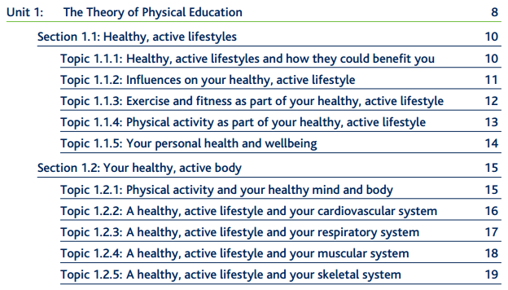
Unit 1 Exam: Friday May 2017
Unit 2 Practical: Tuesday 04th April 2017

GCSE Spanish
Exam board: AQA
Unit 1: Reading - 35/45 mins
Unit 2: Listening – 30/50 mins
- Lifestyle
Health- Healthy and unhealthy lifestyles and their consequences.
Relationships and Choices – Family & friends, future plans, marriage
2. Leisure
Freetime and media – Freetime activities, shopping,money,fashion
Holidays – Plans, preferences, experiences,what to see,getting around
3. Home and Environment
Home & local area –special occasions,home,town,region & neighbourhood
Environment – current problems, being environmentally friendly
4. Work and education
School & college future plans – what school is like, pressures & problems
Current & future jobs – Looking for & getting a job, advantages/disadvantages

Exams: 19th May 2017 – 9:00
GCSE English
Exam board: AQA
This is a holistically assessed curriculum based on the following Assessment Objectives
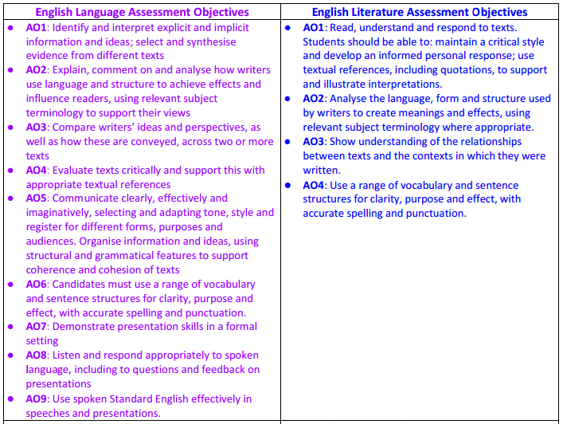
Mon 22 May | 09:30 | 01:45 | AQA | English Literature Paper 1
Fri 26 May | 09:30 | 02:15 | AQA | English Literature Paper 2
Tue 06 Jun | 09:30 | 01:45 | AQA | English Language Paper 1
Mon 12 Jun | 09:30 | 01:45 | AQA | English Language Paper 2

GCSE Science
Exam board: Edexcel

CORE SCIENCE (Dr. Moore / Mr. O'Shea/Mr. Houseman) | SEPARATE SCIENCE (Miss Harding)
Unit B1: Influences on life | Unit B3: Using Biology
Topic 1 Classification, variation and inheritance | Topic 1 Control systems
Topic 2 Responses to a changing environment | Topic 2 Behaviour
Topic 3 Problems of, and solutions to a changing environment | Topic 3 Biotechnology
Unit C1: Chemistry in our world | Unit C3: Chemistry in action
Topic The Earth’s sea and atmosphere | Topic 1 Qualitative analysis
Topic 2 Materials from the Earth | Topic 2 Quantitative analysis
Topic 3 Acids | Topic 3 Electrolytic Processes
Topic 4 Obtaining and using metals | Topic 4 Gases, equilibria and ammonia
Topic 5 Fuels | Topic 5 Organic chemistry
Unit P1: Universal physics
Topic 1 Visible light and the Solar System | Unit P3: Applications of physics
Topic 2 The electromagnetic spectrum | Topic 1 Radiation in treatment and medicine
Topic 3 Waves and the Universe | Topic 2 X-rays and ECGs
Topic 4 Waves and the Earth | Topic 3 Production, uses and risks of ionising radiation from radioactive sources
Topic 5 Generation and transmission of electricity | Topic 4 Motion of particles
Topic 6 Energy and the future | Topic 5 Kinetic theory and gases
ADDITIONAL SCIENCE (Dr. Moore / Mr. O'Shea)
Unit B2: The components of life
Topic 1 The building blocks of cells
Topic 2 Organisms and energy
Topic 3 Common systems
Unit C2: Discovering chemistry
Topic 1 Atomic structure and the periodic table
Topic 2 Ionic compounds and analysis
Topic 3 Covalent compounds and separation techniques
Topic 4 Groups in the periodic table
Topic 5 Chemical reactions
Topic 6 Quantitative chemistry
Unit P2: Physics for your future
Topic 1 Static and current electricity
Topic 2 Controlling and using electric current
Topic 3 Motion and forces
Topic 4 Momentum, energy, work and power
Topic 5 Nuclear fission and nuclear fusion
Topic 6 Advantages and disadvantages of using radioactive materials

Exams
Tue 16 May | 13:30 | 01:00 | EDEXL/GCSE | Influences on Life
Thu 18 May | 09:30 | 01:00 | EDEXL/GCSE | Chemistry in Our World
Wed 24 May | 13:30 | 01:00 | EDEXL/GCSE | Universal Physics
Fri 09 Jun | 09:30 | 01:00 | EDEXL/GCSE | Components of Life
Wed 14 Jun | 09:30 | 01:00 | EDEXL/GCSE | Discovering Chemistry
Fri 16 Jun | 09:30 | 01:00 | EDEXL/GCSE | Physics for Your Future
Mon 19 Jun | 09:30 | 01:00 | EDEXL/GCSE | Using Biology
Wed 21 Jun | 09:30 | 01:00 | EDEXL/GCSE | Chemistry in Action
Fri 23 Jun | 09:30 | 01:00 | EDEXL/GCSE | Application of Physics

