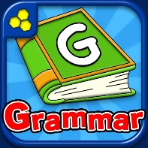
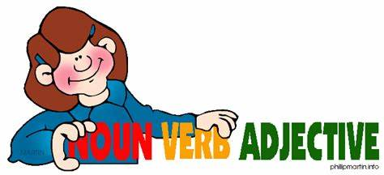

Name: ………………………………………………………………………………
Grammar and Punctuation – EAL lesson 2
Review: Circle the one correct alternative in the following sentences:
- I had to tie my shoe lace because it was lose/loose.
She thought that the hockey team were going to lose/loose the match.
- Her GCSE result was quiet/quite good.
It is time to be quiet/quite because the teacher is coming in.
- We breath/breathe through our lungs.
He was very close to the window and his breath/breathe made the pane steam up.
- Your/You’re going to need as much of your/you’re strength to finish the race in under 20 minutes.
- Just as we were/where going to arrive at the restaurant, my driver told me that he had forgotten were/where it was.
Grammar:
In order to use language properly and correctly, we need to understand how it is constructed. We use grammar and parts of speech in order to do that. Define these parts of speech and give examples:
Part of Speech | Definition | Examples
Verb

Adverb

Common Noun
Proper Noun

Abstract Noun

Noun plural
Pronoun

Possessive pronoun
Adjective

Preposition
Conjunction

Label the different parts of speech:
his | but | in | by
make | slowly | black | LIverpool
quickly | your | eat | he
on | difficult | we | fantastic
mates | start | John | run
easy | she | and | Millie
for | boys | book | boredom
smoke | sadness | fast | pencil

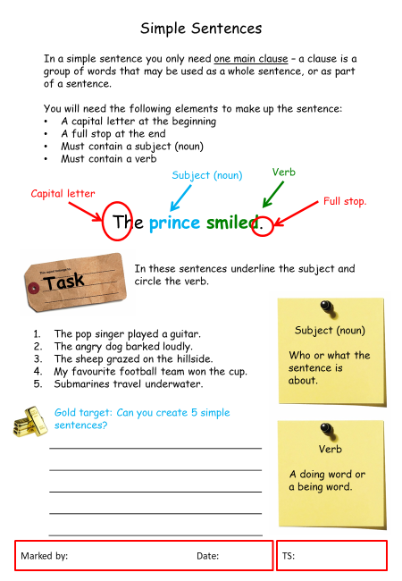
Write a description of one of the following pictures. Focus on using proper sentences, with capital letters, verbs and full stops.



