Spanish Department Themes & Timeframe

SPECIFICATION LINK:
https://filestore.aqa.org.uk/resources/spanish/specifications/AQA-8698-SP-2016.PDF
Provisional Examination Dates 2021:
Speaking (March/April)
Reading, Listening and Writing (May/June)

Year 1
Autumn Term | Basics  Revison-Diagnosis | Theme 1 Topic 2 & 3 | Theme 1: Identity and culture | Topic 2:  Technology in everyday life  Topic 3:  Free-time activities
Spring Term |  | Theme 1 Topic 1 & 4  Theme 3  Topic 4 | Theme 3: Current and future study and employment  Theme 1: Identity and culture | Topic 4:  Jobs, career choices and ambitions  Topic 1:  Me, my family and friends  Topic 4:  Customs and festivals in Spanish-speaking countries/communities
Summer Term |  | Mocks  Theme 2 4 | Theme 2: Local, national, international and global areas of interest | Topic 4:  Travel and tourism

Year 2
Autumn Term KS3 | Revison | Theme 3: Current and future study and employment | Topic 1:  My studies  Topic 2:  Life at school/college  Topic 3: Education post-16  Topic 4:  Jobs, career choices and ambitions
 | Theme 2 1-3 | Theme 2: Local, national, international and global areas of interest | Topic 1:  Home, town, neighbourhood and region  Topic 2:  Social issues  Topic 3:  Global issues  *Healthy living (cross-topics)  *Festivals (cross-topics)
 | Mocks
Spring Term |  | Mocks  Revision & Exam Prep
April- May |  | Speaking Exams
May |  | Exam Prep

EXAM INFO
PAPER 1: LISTENING
Written exam: 35 mins (Foundation) 45 minutes (Higher Tier) 40 marks (F) 50 marks (H)
25% of GCSE
(Each exam includes 5 minutes’ reading time of the question paper)
- Section A – questions in English, to be answered in English or non-verbally.
- Section B – questions in Spanish, to be answered in Spanish or non-verbally
PAPER 2: SPEAKING
Duration 7-9 minutes (F) 10–12 minutes (H) + Prep. time (12 minutes) 60 marks (for both F and H)
25% of GCSE
- Role-play – 15 marks (2 minutes 2 minutes at Higher Tier)
- Photo card – 15 marks (3 minutes at Higher Tier)
- General conversation – 30 marks (5–7 minutes at Higher Tier)
PAPER 3: READING
Written exam: 45 mins (Foundation) 1 hour (Higher) 60 marks (for both F and H)
25% of GCSE
- Section A – questions in English, to be answered in English or non-verbally.
- Section B – questions in Spanish to be answered in Spanish or non-verbally.
- Section C – translation from Spanish into English.
PAPER 4: WRITING
Written exam: 1 hour (Foundation) 1 hour and 15 minutes (Higher) 50 marks (F) 60 marks (H)
25% of GCSE
FOUNDATION
- Question 1 – message (four sentences in response to a photo) – 8 marks
- Question 2 – short passage (four brief bullet points, approx.. 40 words in total) – 16 marks
- Question 3 – translation from English into Spanish (minimum 35 words) – 10 marks
- Question 4 – structured writing task (four compulsory detailed bullet points, producing approximately 90 words in total) – there is a choice from two questions – 16 marks
HIGHER
- Question 1 – structured writing task (student responds to four compulsory detailed bullet points, producing approximately 90 words in total) – there is a choice from two questions – 16 marks.
- Question 2 – open-ended writing task (student responds to two compulsory detailed bullet points, producing approximately 150 words in total) – there is a choice from two questions – 32 marks.
- Question 3 – translation from English into Spanish (minimum 50 words) – 12 marks.
GCSE SPANISH THEMES & TOPICS LIST
Theme 1 (4 booklets) Identity and culture
Topic 1: Me, my family and friends
Topic 2: Technology in everyday life
Topic 3: Free-time activities
Topic 4: Customs and festivals in Spanish-speaking countries/communities
Theme 2 (3 booklets) Local, national, international and global areas of interest
Topic 1: Home, town, neighbourhood and region
Topic 2: Social issues: Charity /Voluntary Work & Healthy/unhealthy Living
Topic 3: Global issues: The environment & Poverty/Homeless
Topic 4: Travel and Tourism
Theme 3 (1 booklet) Current and future study and employment
Topic 1: My studies
Topic 2: Life at school/college
Topic 3: Education post-16
Topic 4: Jobs, career choices and ambitions
FLOWCHART BOOKLETS CHECK LIST
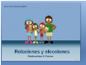
Theme 1
Las relaciones
La tecnología
El tiempo libre
Las fiestas
Theme 2
El medio ambiente
La salud
De vacaciones
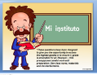
Theme 3
Mi instituto
Trabajo
DAILY REVISION AT HOME
DAILY REVISION:
All class resources are available at www.missmallo.weebly.com
Students should revise GCSE vocab daily for at least 15 mins with www.memrise.com
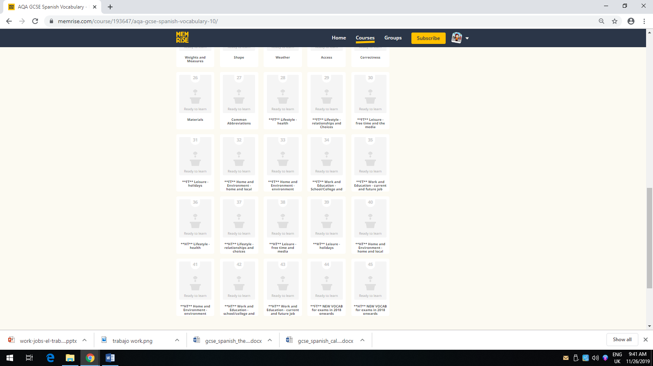
Foundation from 28-35
Higher from 28-43
Both 44-45
Encourage your child to:
- Watch films, shows, documentaries, short videos in Spanish with English subtitles making notes of the new vocabulary.
- Listen to Spanish songs to learn vocabulary and pronunciation.
- Read adapted books in Spanish.
- Read newspapers, blogs, literature extracts and articles in Spanish.
- Practice memory techniques learning expressions, poems or short passages in Spanish.
- Listen to and/or create Spanish podcasts.
- Speak in Spanish at home.

QUESTIONS FOR SPEAKING GENERAL CONVERSATION
PART 1 ROLEPLAY (Any Theme)
PART 2 PHOTOCARD (Theme 2 or Theme 3)
PART 3 GENERAL CONVERSATION (Theme 1+ Either Theme 2 or 3- not covered in PHOTO)
FOUNDATION
QUESTIONS CHECK LIST
THEME 1
- 1.¿Qué opinas de la tecnología?
What do you think about technology?
- 2.¿Qué te gusta hacer en tu tiempo libre?
What do you like doing on your free time?
- 3.¿Qué vas a hacer este fin de semana en tu tiempo libre?
What are you going to do this weekend in your free time?
- 4.Háblame sobre tu fiesta favorita en España (present)
Tell me about your favorite festival in Spain
- 5.Hablame de tu familia (present)
Tell me about you familia

THEME 2
- 6 .Si tuvieras tiempo ¿Como ayudarías en la sociedad?
If you had time How would you help in society?
- 7.¿Te preocupa el medio ambiente?
Are you worried about the environment?
- 8.¿Qué tipos de problemas sociales hay en tu barrio?
What kind of social issues are there in your neighbourhood?
- 9.¿Qué vas a hacer en tus próximas vacaciones ?
What are you going to do in your next holidays?
- 10.¿Estas en forma?
Are you fit?

THEME 3
- 11.¿Qué vas a hacer en el futuro?
What are you going to do in the future?
- 12.En tu opinión ¿Cuales son los problemas de los estudiantes en el instituto?
What would you suggest to improve your school?

HIGHER
QUESTIONS CHECK LIST
THEME 1
- 1.¿Qué opinas de la tecnología?
What do you think about technology?
- 2.¿Qué ventajas o desventajas tiene la tecnología?
What advantages or disadvantages has technology got ?
- 3.¿Qué te gusta hacer en tu tiempo libre?
What do you like doing on your free time?
- 4.¿Qué solías hacer en tu tiempo libre en el pasado?
What did you used to do in your free time in the past?
- 5.¿Qué vas a hacer este fin de semana en tu tiempo libre?
What are you going to do this weekend in your free time?
- 6.¿Qué piensas de las fiestas españolas?
What do you think of Spanish festivals?
- 7. ¿Has ido a alguna fiesta local en España?
Have you ever been to a Spanish festival?
- 8.Hablame de tu familia ideal (conditional)
Tell me about your ideal family

THEME 2
- 9.Si tuvieras tiempo ¿Como ayudarías en la ociedad?
If you had time How would you help in society?
- 10.¿Te preocupa el medio ambiente?
Are you worried about the environment?
- 11.¿Qué tipos de problemas sociales hay en tu barrio?
What kind of social issues are there in your neighbourhood?
- 12.¿Qué vas a hacer en tus próximas vacaciones ?
What are you going to do in your next holidays?
- 13. ¿Cual fue el momento mas memorable en tus vacaciones?
What was the most memorable event on your holidays?
- 14.¿Qué sugerirías para ser mas saludable?
What would you suggest to be healthier?

THEME 3
- 15.¿Qué vas a hacer después de tus exámenes?
What are you going to do after your GCSEs?
- 16.¿Qué sugerirías para mejorar tu instituto?
What would you suggest to improve your school?
- 17.En tu opinión ¿Cuales son los problemas de los estudiantes en el instituto?
What would you suggest to improve your school?

GCSE WRITING
Paper 4 WRITING:
FOUNDATION Written exam: 1 hour (Foundation 50 marks (F)
- Question 1 – message (four sentences in response to a photo) – 8 marks
- Question 2 – short passage (four brief bullet points, approx.. 40 words in total) – 16 marks
- Question 3 – translation from English into Spanish (minimum 35 words) – 10 marks
- Question 4 – structured writing task (four compulsory detailed bullet points, producing approximately 90 words in total) – there is a choice from two questions – 16 marks
To prepare for this exam you need to:
- Complete all flowcharts from all topics. (See check list sheet)
- After being marked and YET feedback given, re-draft making corrections and improvements in GREEN form.
- Check all the requirements below to get the highest grade possible.
Writing Composition Check List FOUNDATION
Foundation
- Check ALL the bullet points.
- 100 palabras (words)
- 3 Opinions
- 3 Justifications (Developed Reasons)
- Simple connectors y, pero, porque, ya que, sin embargo, consecuentemente
- Spanish expressions
- Spanish facts
- 3 Tenses
- Translate all your essays from the flowcharts as you go along in BLUE
- Memorise one essay for each topic. (It would be useful)
- Practice the formats.
- Letter Carta Postcard Postal Email Correo Electrónico
- Blog Blog o página web
- Essay Redacción
- Invitation Invitación
- Competition Concurso/Competición

HIGHER Written exam: 1 hour 15 mins (Higher 60 marks)
- Question 1 – structured writing task (student responds to four compulsory detailed bullet points, producing approximately 90 words in total) – there is a choice from two questions – 16 marks.
- Question 2 – open-ended writing task (student responds to two compulsory detailed bullet points, producing approximately 150 words in total) – there is a choice from two questions – 32 marks.
- Question 3 – translation from English into Spanish (minimum 50 words) – 12 marks.
To prepare for this exam you need to:
- Complete all flowcharts from all topics. (See check list sheet)
- After being marked and YET feedback given, re-draft making corrections and improvements in GREEN form.
- Check all the requirements below to get the highest grade possible.
Writing Composition Check List HIGHER
Higher
- Check ALL bullet points
- At least 175 palabras (words)
- At least 3 Opinions
- At least 3 Justification (detailed reasons)
- 5 Tenses
- Talk about yourself
- Talk about somebody else
- Examples
- Complex Connectors (see higher structure booklet)
- Extra details
- Variety of vocabulary
- Original content
- Spanish expressions
- Spanish facts
- Well structured (2-4 paragraphs) Introduction/ Body (Positive & Negative)/Conclusion
- Translate all your essays from the flowcharts as you go along in BLUE
- Memorise one essay for each topic. (It would be useful)
- Practice the formats.

- Letter Carta Postcard Postal Email Correo Electrónico
- Blog Blog o página web
- Essay Redacción
- Invitation Invitación
- Competition Concurso/Competición

